# 

# 

# 

# Course: ENSF 614 - Fall 2023

# Lab B01: Lab 1

# Instructor: Mahmood Moussavi

# Student Name: Braden Tink

# Submission Date: September , 2023

## 

## 

## 

## 

## 

## 

## 

## Lab1 Exe A (Omited)

## Lab1 Exe B

#### Code

/*

* lab1exe_B.cpp

* ENSF 614 Lab 1, exercise B

* Created by Mahmood Moussavi

* Completed by: Braden Tink

* Submission Date: Sept 20, 2023

*/

#include <iostream>

#include <cmath>

using namespace std;

const double G = 9.8; /* gravitation acceleration 9.8 m/s^2 */

const double PI = 3.141592654;

void create_table(double v);

double Projectile_travel_time(double a, double v);

double Projectile_travel_distance(double a, double v);

double degree_to_radian(double d);

void create_table(double v){

double angle;

double radians;

double distance;

double time;

cout << "Angle t d\n";

cout << "(deg) (sec) (m)\n";

angle = 0;

while ( angle <= 90){

radians = degree_to_radian(angle);

distance = Projectile_travel_distance(radians, v);

time = Projectile_travel_time(radians, v);

cout << angle << " " << time << " " << distance << "\n";

angle += 5.0;

}

}

double Projectile_travel_time(double a, double v){

return ((2*v*sin(a))/G);

}

double Projectile_travel_distance(double a, double v){

return ((v*v)/G)*sin(2*a);

}

double degree_to_radian(double d){

return (d*PI)/180;

}

int main(void)

{

double velocity;

cout << "Please enter the velocity at which the projectile is launched (m/sec): ";

cin >> velocity;

if(!cin) // means if cin failed to read

{

cout << "Invlid input. Bye...\n";

exit(1);

}

while (velocity < 0 )

{

cout << "\nplease enter a positive number for velocity: ";

cin >> velocity;

if(!cin)

{

cout << "Invlid input. Bye...";

exit(1);

}

}

create_table(velocity);

return 0;

}

#### 

#### 

#### Output

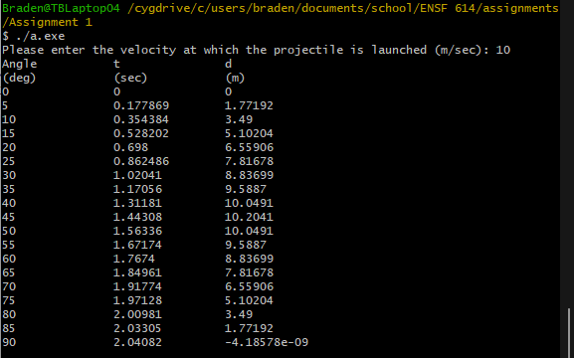

## Lab1 Exe C

(Omitted)

## Lab1 Exe D

### Part 1 (Omitted)

### Part 2

## 

## Lab1 Exe E

#### Code

/*

* lab1exe_E.cpp

* ENSF 614 Lab 1, exercise E

* Created by Mahmood Moussavi

* Completed by: Braden Tink

* Submission Date: Sept 20, 2023

*/

#include <iostream>

using namespace std;

void time_convert(int ms_time, int *minutes_ptr, double *seconds_ptr);

/*

* Converts time in milliseconds to time in minutes and seconds.

* For example, converts 123400 ms to 2 minutes and 3.4 seconds.

* REQUIRES:

* ms_time >= 0.

* minutes_ptr and seconds_ptr point to variables.

* PROMISES:

* 0 <= *seconds_ptr & *seconds_ptr < 60.0

* *minutes_ptr minutes + *seconds_ptr seconds is equivalent to

* ms_time ms.

*/

int main(void)

{

int millisec;

int minutes;

double seconds;

cout << "Enter a time interval as an integer number of milliseconds: ";

// printf("Enter a time interval as an integer number of milliseconds: ");

cin >> millisec;

if (!cin) {

cout << "Unable to convert your input to an int.\n";

exit(1);

}

cout << "Doing conversion for input of " << millisec <<" milliseconds ... \n,";

time_convert(millisec, &minutes, &seconds);

/* MAKE A CALL TO time_convert HERE. */

cout << "That is equivalent to " << minutes << " minute(s) and " << seconds << " second(s).\n";

return 0;

}

/* PUT YOUR FUNCTION DEFINITION FOR time_convert HERE. */

void time_convert(int ms_time, int *minutes_ptr, double *seconds_ptr){

int remainder;

if (ms_time <= 60000){

*minutes_ptr = 0;

*seconds_ptr = (ms_time / 1000);

}

else{

remainder = ms_time % 60000;

*minutes_ptr = (ms_time /60000);

*seconds_ptr = (remainder / 1000);

}

}

#### Output

